

High Level Design (HLD)

Bank Marketing Analytics

Revision Number: 1.0

Last date of revision: 08/01/2023

Akhilesh Buxi Pattanaik

Abhijeet Sethy



High Level Design (HLD)

**Document Version Control:**

|  |  |  |  |
| --- | --- | --- | --- |
| **Date Issued** | **Version** | **Description** | **Author** |
| **12th January 2023** | 1.0 | First Version of Complete HLD | Akhilesh Buxi Pattanaik  Abhijeet Sethy |

[AUTHOR NAME]



High Level Design (HLD)

**Contents**

**Document Version Control**....................................................................................................................................3.2 **Abstract**..............................................................................................................................4

1 **Introduction**…….…………………….................................................................................5

1.1 Why this High-Level Design Document?.........................................................................5 1.2 Scope ................................................................................................................................5

2 **General Description** ...........................................................................................................6 2.1 Product Perspective & Problem Statement .......................................................................6

2.2 Tools used.........................................................................................................................6 3 **Design Details**.....................................................................................................................7 3.1 Functional Architecture ....................................................................................................7 3.2 Optimization .....................................................................................................................7 4 **KPIs**.....................................................................................................................................8 4.1 KPIs (Key Performance Indicators) .................................................................................8 **Deployment**............................................................................................................................9

[AUTHOR NAME]



High Level Design (HLD)

**Abstract**

Nowadays, marketing spending in the banking industry is massive, meaning that it is essential for banks to optimize marketing strategies and improve effectiveness. Understanding customers’ need leads to more effective marketing plans, smarter product designs and greater customer satisfaction.

The increasing number of marketing campaigns has devalued their impact on the general public over time. Furthermore, economic pressures and competition have led marketing managers to invest in targeted campaigns with a strict and rigorous contact selection. Such direct campaigns can be improved by employing Business Intelligence (BI) and Data Mining (DM) techniques.

High Level Design (HLD)

**1 Introduction**

**1.1 Why this High-Level Design Document?**

The purpose of this High-Level Design (HLD) Document is to add the necessary detail to the current project description to represent a suitable model. This document is also intended to help detect contradictions prior to coding, and can be used as a reference manual for how the modules interact at a high level.

**1.2 Scope**

To evaluate whether or not the product (a bank term deposit) will be subscribed by having many interactions with the same customer.

High Level Design (HLD)

**2 General Description**

**2.1 Product Perspective & Problem Statement**

This project will allow the bank to obtain a more detailed understanding of its prospective customers, understand behaviour of customer responses to telemarketing campaigns, and create a target customer profile for future marketing plans.

The bank will be able to understand the customer saving behaviours and identify which types of customers are more likely to make term deposits by analysing customer features such as demographics and transaction history. The bank can then target those customers with its marketing efforts. This will not only allow the bank to secure deposits more effectively, but it will also increase customer satisfaction by removing advertisements that are unsuitable for certain customers.

The objective of the project is to perform data visualization techniques to understand the insight of the data. In this project we used Microsoft Power BI to get a visual understanding of the data.

* 1. **Tools used**

Business Intelligence tools such as Excel, Power BI, MS SQL server Database are used to build the whole framework.

* The full dataset was initially converted from csv to excel format using Numpy in a Jupyter notebook. The data was then cleaned in Excel based on univariate analysis for each number column.
* MS Excel is used to clean the data, remove outliers and unwanted columns also tried to add some additional features and group parameters for better visualisation.
* Load the data in SQL Server and create a link with Power BI using SQL server gateway available in Power BI.
* Power BI is used to build interactive visuals, Dashboards with live integration of SQL server. So that whenever there is additional data updated in the server the Visuals will get auto updated.

 



High Level Design (HLD)

**3 Design Details**

**3.1 Functional Architecture**

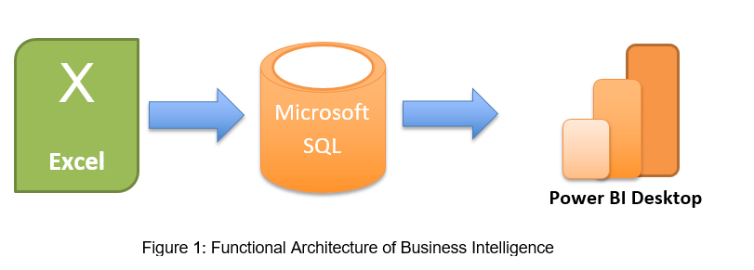

First the raw data which was given by the client in .CSV format was uploaded in Excel and done brainstorming session to understand the data. There are some unwanted columns which was deleted. Then efforts are made to clean the raw data and remove outliers. Post that the whole data is loaded into SQL server.

In SQL server several queries are written for Documentation and verification purpose and compare results in Power BI.

Post that through Power BI Gateway a link was established with SQL server with direct query mode to make the data available in Power BI for visualisation purpose.

**3.2 Optimization**

**Your data strategy drives performance**

* Minimize the number of records
* Optimize extracts to speed up future queries by materializing calculations, removing columns and the use of accelerated views

**Reduce the marks (data points):** Unwanted Data points like call duration <5s, Education category having “**Other**” are removed.

**Optimize and materialize your calculations:** Further the Age, balance and Duration column has been categorized as Age category, Financial Category and Call-Duration category respectively for better visualization.

[AUTHOR NA



High Level Design (HLD) 

**4 KPIs**

Dashboards will be implemented to display and indicate certain KPIs and relevant indicators for the Campaign Analytics. As and when, the system starts to capture the historical/periodic data for a user, the dashboards will be included to display charts over time with progress on various indicators or factors.

**4.1 KPIs (Key Performance Indicators)**

In this project key indicators displaying a summary of the response and its relationship with different metrics

1. Impact of Age category on positive response
2. Impact of Income group on positive response
3. Influence of Education on positive response
4. Influence of Job type on positive response
5. Influence of personal loan parameter on positive response
6. Influence of previous campaign parameter on positive response
7. Influence of duration of call with agent on positive response
8. Influence of time of call like day or month in a year for positive response

]

High Level Design (HLD)

**5 Deployment**

The final report is published in Power BI service. Then the link is shared to client. Below is the document link to access the report.

**Link:** <https://app.powerbi.com/view?r=eyJrIjoiMjJlOWVmNmEtMmU3Zi00NWM1LWE5ZmYtZTNiOGZkMTE1Mzc0IiwidCI6ImRmODY3OWNkLWE4MGUtNDVkOC05OWFjLWM4M2VkN2ZmOTVhMCJ9&pageName=ReportSection>

Also the entire project is uploaded in Novypro.com for public use.

Link: <https://www.novypro.com/project/abpattanaik96novyprocom>

[